PYTHON PROGRAMMING
CASE STUDIES
Algorithms • Flowcharts • Pseudocode • Source Code • Test Cases

Subject | Python Programming
Document | Case Study Collection
Currency used in examples | Indian Rupees (₹)

Prepared from the supplied case-study material

Contents
- Program 1: Scholarship Eligibility System
- Program 2: Electricity Bill Calculation
- Program 3: Hospital Billing System
- Program 4: Employee Salary Calculation System
- Program 5: Mobile Data Plan Selection System
- Program 6: Railway Fare Calculation System
- Program 7: Retail Billing System with Discount and Tax
- Program 8: Manufacturing Profit Calculation System
- Program 9: Foreign Travel Expense and Budget Management
- Program 11: Event Management Break-Even Calculator
Note: The supplied source labels the final case study as Program-11. No Program-10 material was present in the source.

Program 1: Scholarship Eligibility System

1. Problem Statement
Determine whether a student qualifies for a scholarship using aggregate marks, subject marks, attendance percentage, and annual family income.

2. Objectives
- Accept aggregate marks, subject marks, attendance percentage, and annual family income.
- Check all eligibility conditions.
- Display whether the student is eligible.

3. Assumptions
- Aggregate marks must be at least 75.
- Subject marks must be at least 60.
- Attendance must be at least 75%.
- Annual family income must not exceed ₹2,50,000.
- All four conditions must be satisfied.

4. Algorithm
- Start.
- Input aggregate marks, subject marks, attendance, and family income.
- Check whether aggregate ≥ 75, subject ≥ 60, attendance ≥ 75, and income ≤ ₹2,50,000.
- If all conditions are true, display “Eligible for Scholarship”; otherwise, display “Not Eligible”.
- Stop.

5. Flowchart
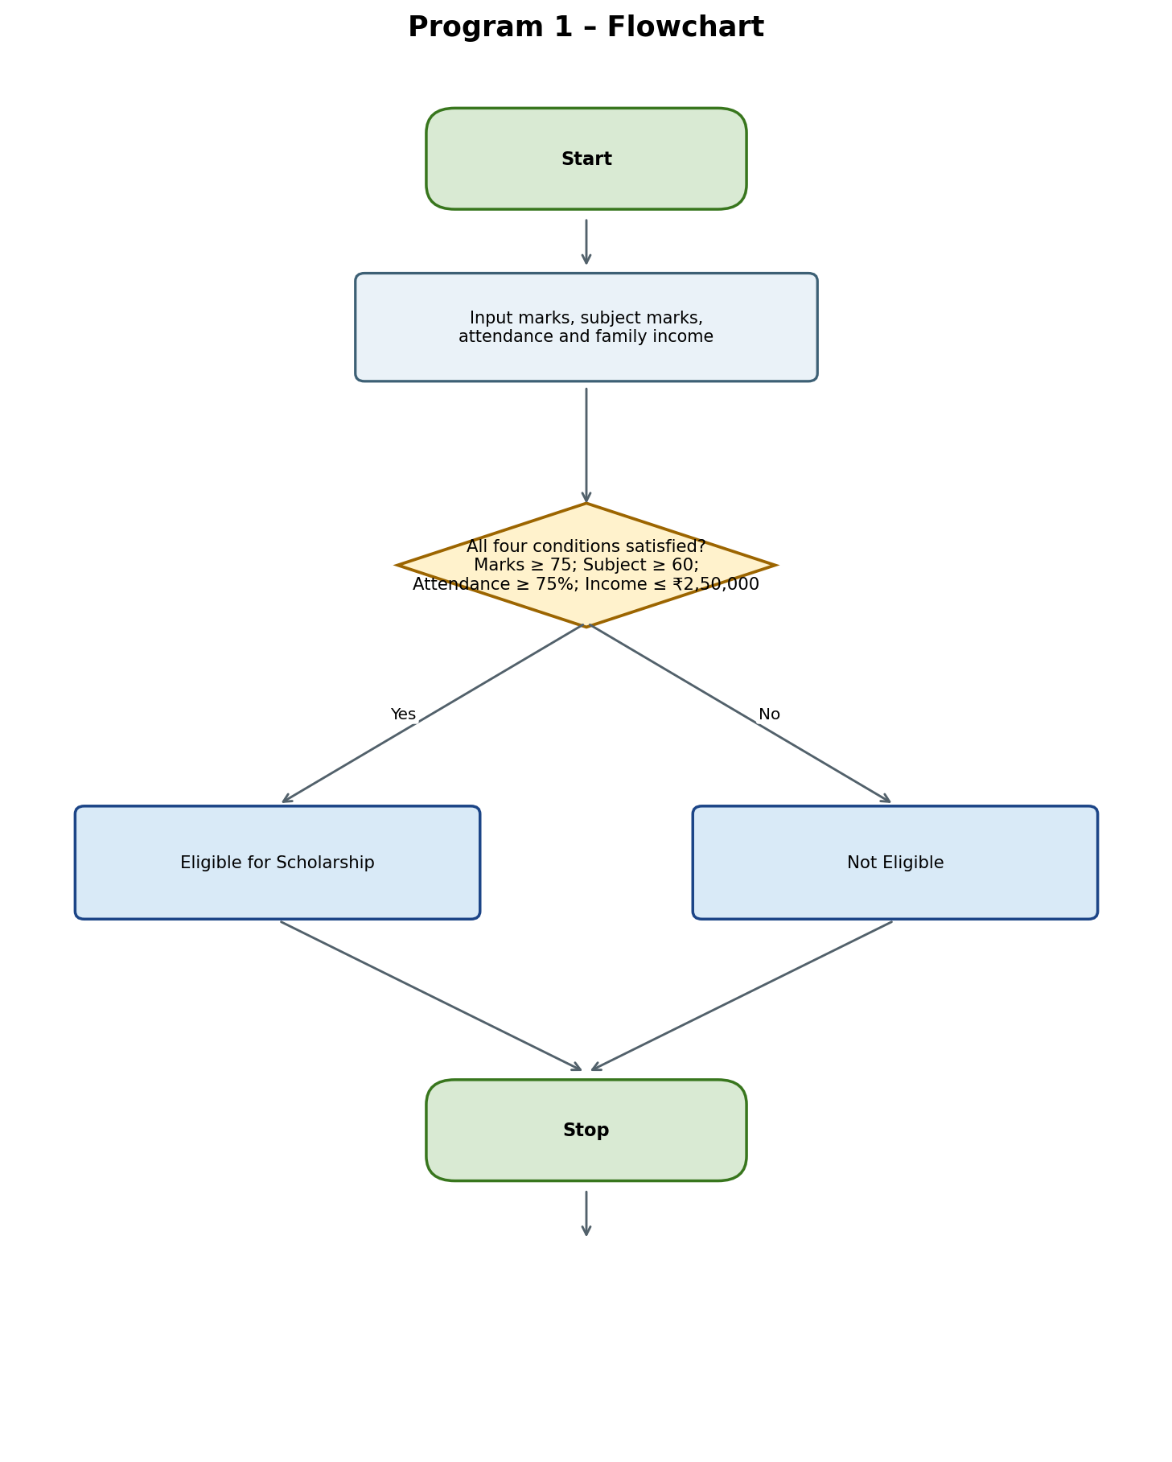

6. Pseudocode
START
INPUT marks, subject, attendance, income
IF marks >= 75 AND subject >= 60 AND attendance >= 75 AND income <= 250000
DISPLAY "Eligible for Scholarship"
ELSE
DISPLAY "Not Eligible"
END IF
STOP

7. Python Source Code
marks = int(input("Aggregate: "))
subject = int(input("Subject marks: "))
attendance = int(input("Attendance: "))
income = int(input("Family income: "))

if marks >= 75 and subject >= 60 and attendance >= 75 and income <= 250000:
print("Eligible for Scholarship")
else:
print("Not Eligible")

8. Test Cases
Test Case 1: Eligible student
Input | Aggregate 85; Subject 70; Attendance 90; Income 200000
Expected output | Eligible for Scholarship
Explanation | All four conditions are satisfied.

Test Case 2: Aggregate below threshold
Input | Aggregate 65; Subject 70; Attendance 90; Income 200000
Expected output | Not Eligible
Explanation | Aggregate marks are below 75.

Test Case 3: Income above limit
Input | Aggregate 85; Subject 70; Attendance 90; Income 300000
Expected output | Not Eligible
Explanation | Family income exceeds ₹2,50,000.

Test Case 4: Exact minimum limits
Input | Aggregate 75; Subject 60; Attendance 75; Income 250000
Expected output | Eligible for Scholarship
Explanation | All values meet the thresholds exactly.

9. Output Screenshots

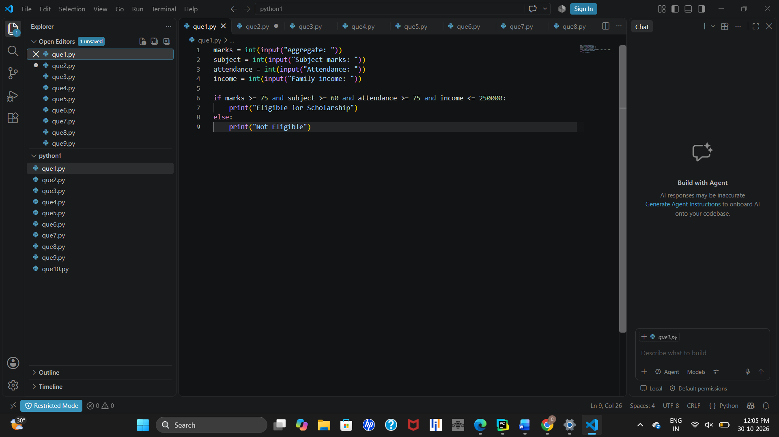610. Conclusion
This system automates scholarship eligibility verification using user input, comparison operators, logical AND, and if-else statements.

Program 2: Electricity Bill Calculation

1. Problem Statement
Calculate a consumer’s electricity bill using progressive consumption slabs and add a fixed charge of ₹50.

2. Objectives
- Accept electricity units consumed.
- Apply the appropriate slab rates.
- Add the fixed charge of ₹50.
- Display the final bill.

3. Assumptions
- Units are a non-negative integer.
- First 100 units: ₹2 per unit.
- Units 101–200: ₹3 per additional unit; the first 100 units cost ₹200.
- Above 200 units: ₹5 per additional unit; the first 200 units cost ₹500.
- Add a fixed charge of ₹50. All amounts are in Indian rupees.

4. Algorithm
- Start and input units consumed.
- If units ≤ 100, bill = units × 2.
- Else if units ≤ 200, bill = 200 + (units − 100) × 3.
- Otherwise, bill = 500 + (units − 200) × 5.
- Add ₹50, display the final bill, and stop.

5. Flowchart
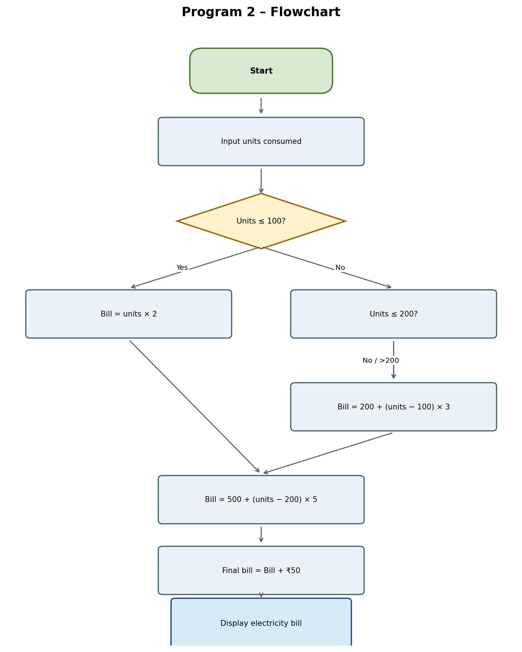

6. Pseudocode
START
INPUT units
IF units <= 100
bill = units * 2
ELSE IF units <= 200
bill = 200 + (units - 100) * 3
ELSE
bill = 500 + (units - 200) * 5
END IF
final_bill = bill + 50
DISPLAY final_bill
STOP

7. Python Source Code
units = int(input("Units: "))

if units <= 100:
bill = units * 2
elif units <= 200:
bill = 200 + (units - 100) * 3
else:
bill = 500 + (units - 200) * 5

print("Electricity Bill:", bill + 50)

8. Test Cases
Test Case 1: 80 units
Input | Units: 80
Expected output | Electricity Bill: 210
Explanation | 80 × ₹2 = ₹160; plus ₹50 fixed charge = ₹210.

Test Case 2: 150 units
Input | Units: 150
Expected output | Electricity Bill: 400
Explanation | ₹200 + (50 × ₹3) = ₹350; plus ₹50 = ₹400.

Test Case 3: 250 units
Input | Units: 250
Expected output | Electricity Bill: 800
Explanation | ₹500 + (50 × ₹5) = ₹750; plus ₹50 = ₹800.

Test Case 4: 100 units
Input | Units: 100
Expected output | Electricity Bill: 250
Explanation | 100 × ₹2 = ₹200; plus ₹50 = ₹250.

9. Output Screenshots

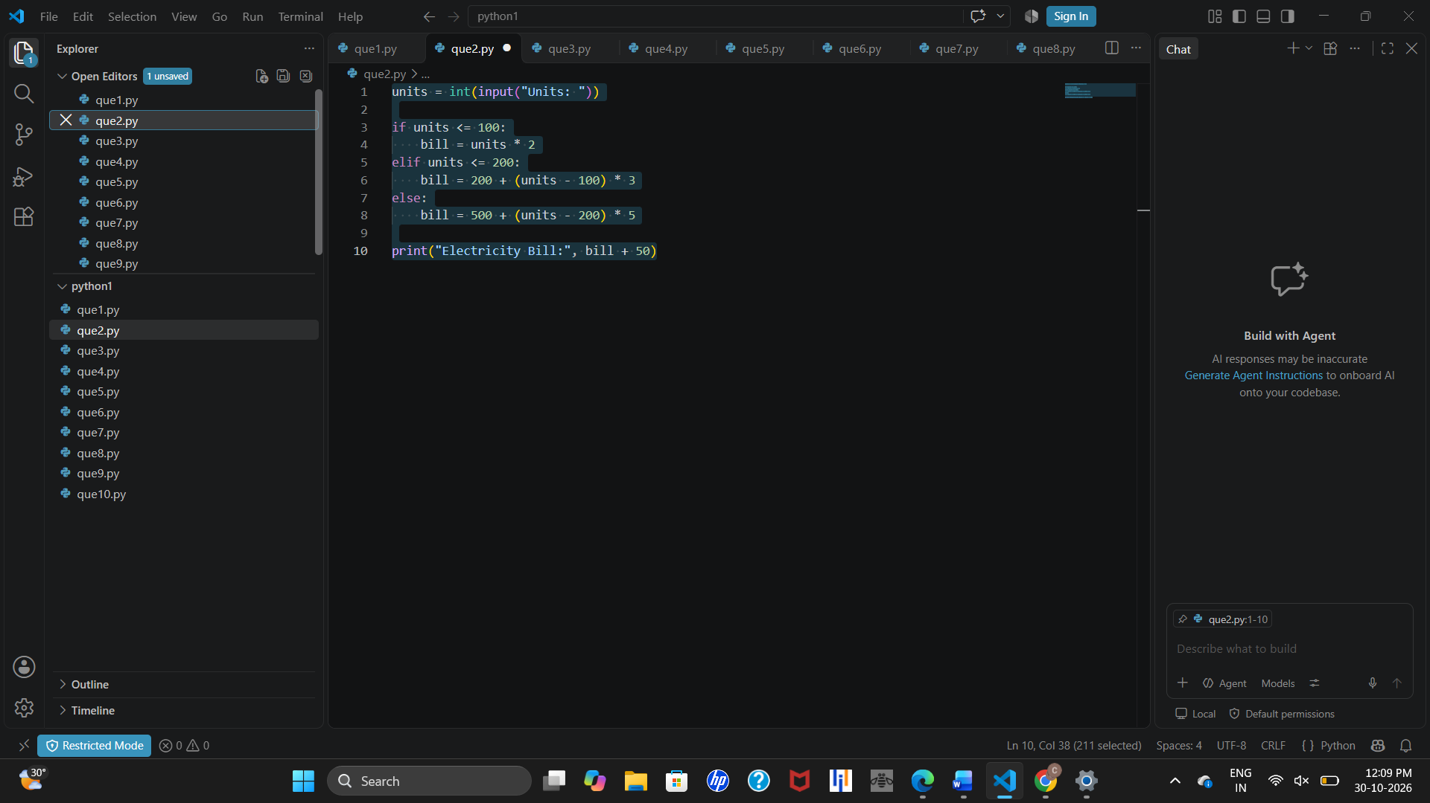10. Conclusion
This program demonstrates slab-based calculations using if, elif, and else statements, arithmetic operations, and user input.
Note: The rates are illustrative assumptions for this exercise and may not match actual electricity tariffs.

Program 3: Hospital Billing System

1. Problem Statement
Calculate a patient’s hospital bill from consultation, diagnostic, and treatment charges, and apply a 10% discount when the total is ₹5,000 or more.

2. Objectives
- Accept consultation, diagnostic, and treatment charges.
- Calculate the total bill.
- Apply a 10% discount at the ₹5,000 threshold.
- Display the final payable amount.

3. Assumptions
- All three charges are non-negative amounts.
- Total bill is the sum of the three charges.
- A 10% discount applies when total bill ≥ ₹5,000; otherwise no discount applies.
- All amounts are in Indian rupees.

4. Algorithm
- Start and input consultation, diagnostic, and treatment charges.
- Calculate bill = consultation + diagnostic + treatment.
- If bill ≥ ₹5,000, subtract 10% of the bill.
- Otherwise retain the original bill.
- Display the hospital bill and stop.

5. Flowchart
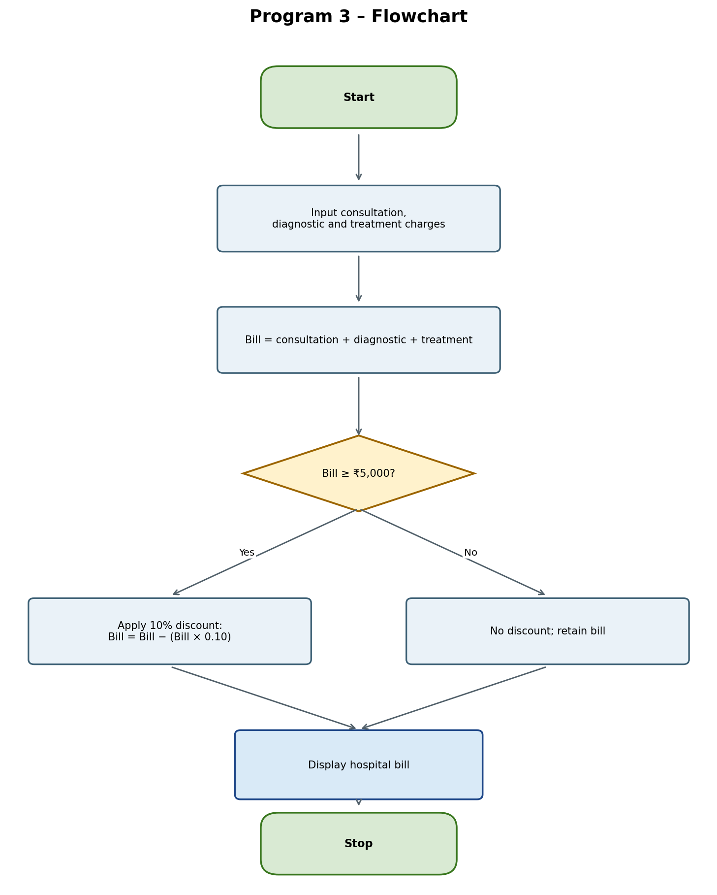

6. Pseudocode
START
INPUT consultation, diagnostic, treatment
bill = consultation + diagnostic + treatment
IF bill >= 5000
bill = bill - (bill * 0.10)
END IF
DISPLAY bill
STOP

7. Python Source Code
c = int(input("Consultation: "))
d = int(input("Diagnostic: "))
t = int(input("Treatment: "))

bill = c + d + t

if bill >= 5000:
bill -= bill * 0.10

print("Hospital Bill:", bill)

8. Test Cases
Test Case 1: Below ₹5,000
Input | Consultation 1000; Diagnostic 1500; Treatment 2000
Expected output | Hospital Bill: 4500
Explanation | Total is ₹4,500, so no discount applies.

Test Case 2: Above ₹5,000
Input | Consultation 2000; Diagnostic 1500; Treatment 2500
Expected output | Hospital Bill: 5400.0
Explanation | Total ₹6,000 less 10% discount (₹600) = ₹5,400.

Test Case 3: Exactly ₹5,000
Input | Consultation 1500; Diagnostic 1500; Treatment 2000
Expected output | Hospital Bill: 4500.0
Explanation | 10% of ₹5,000 is ₹500; final bill is ₹4,500.

9. Output Screenshots

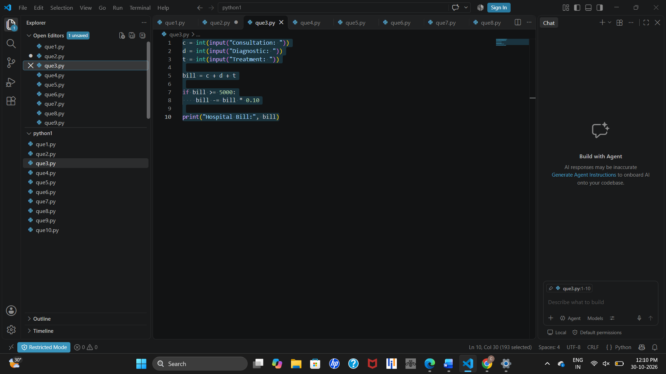10. Conclusion
This case study demonstrates arithmetic operations and a conditional percentage discount using variables, input, and if statements.

Program 4: Employee Salary Calculation System

1. Problem Statement
Calculate gross and net salary from basic salary, allowances, overtime pay, and incentives, applying a 10% deduction to gross salary.

2. Objectives
- Accept basic salary, allowances, overtime, and incentives.
- Calculate gross salary.
- Deduct 10% from gross salary.
- Display gross and net salary.

3. Assumptions
- All salary components are non-negative amounts.
- Gross salary is the sum of the four components.
- A deduction of 10% of gross salary is applied.
- All amounts are in Indian rupees.

4. Algorithm
- Start and input basic salary, allowances, overtime, and incentives.
- Calculate gross = basic + allowances + overtime + incentive.
- Calculate deduction = gross × 0.10.
- Calculate net = gross − deduction.
- Display gross and net salary; stop.

5. Flowchart
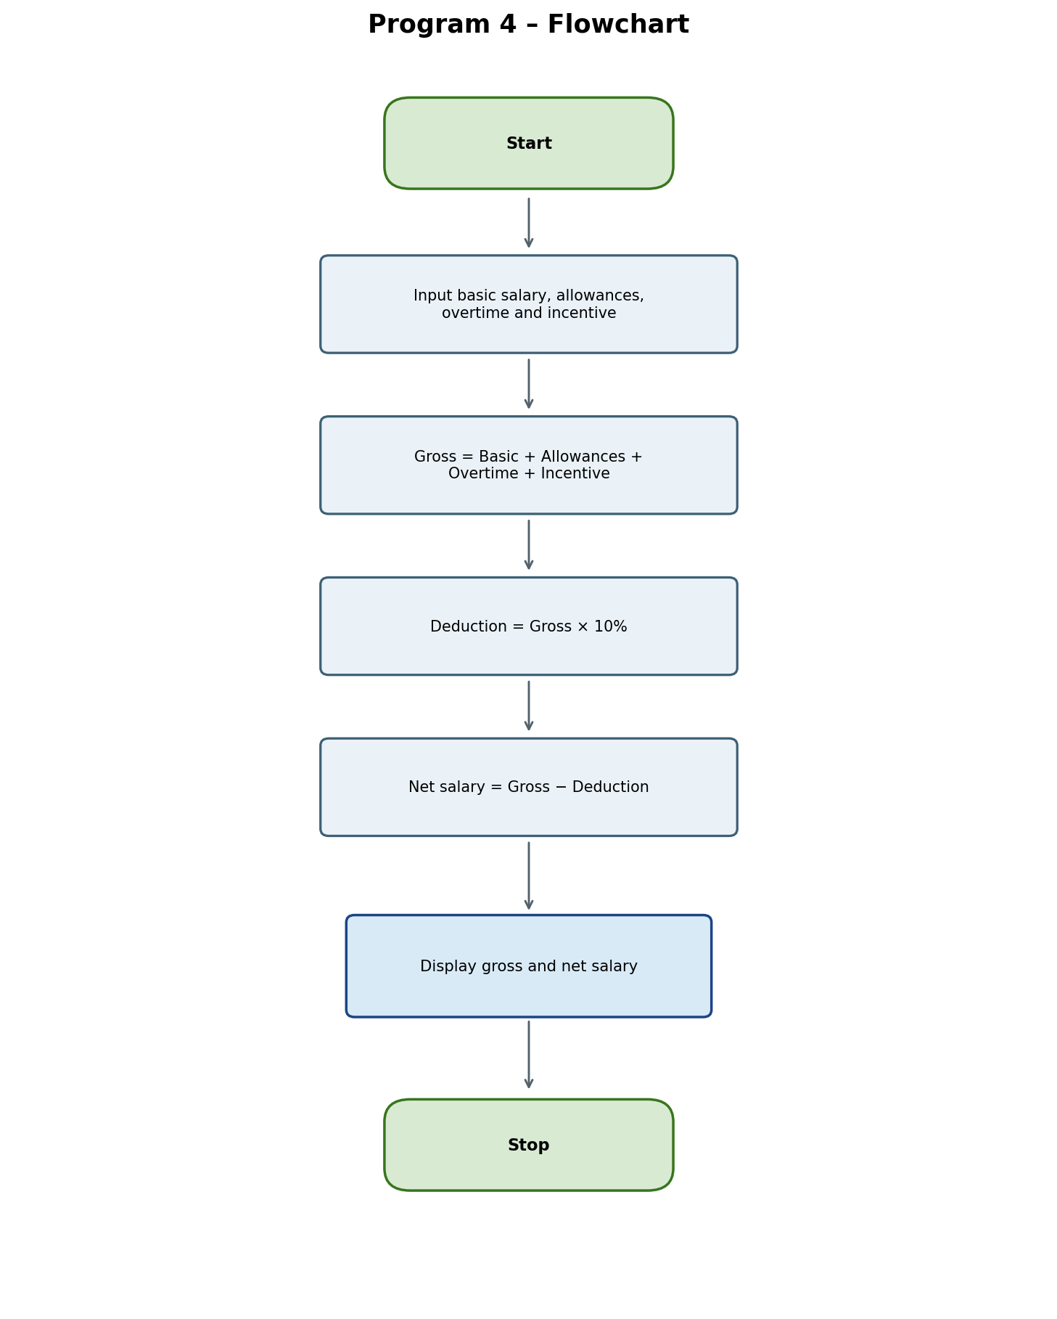

6. Pseudocode
START
INPUT basic, allowance, overtime, incentive
gross = basic + allowance + overtime + incentive
deduction = gross * 0.10
net = gross - deduction
DISPLAY gross, net
STOP

7. Python Source Code
basic = int(input("Basic salary: "))
allowance = int(input("Allowances: "))
overtime = int(input("Overtime: "))
incentive = int(input("Incentive: "))

gross = basic + allowance + overtime + incentive
net = gross - gross * 0.10

print("Gross:", gross)
print("Net Salary:", net)

8. Test Cases
Test Case 1: Standard salary
Input | Basic 20000; Allowances 5000; Overtime 2000; Incentive 3000
Expected output | Gross: 30000; Net Salary: 27000.0
Explanation | Gross ₹30,000; deduction ₹3,000; net ₹27,000.

Test Case 2: Higher earnings
Input | Basic 35000; Allowances 8000; Overtime 4000; Incentive 3000
Expected output | Gross: 50000; Net Salary: 45000.0
Explanation | Gross ₹50,000; deduction ₹5,000; net ₹45,000.

Test Case 3: Basic salary only
Input | Basic 15000; other components 0
Expected output | Gross: 15000; Net Salary: 13500.0
Explanation | Gross ₹15,000; deduction ₹1,500; net ₹13,500.

9. Output Screenshots

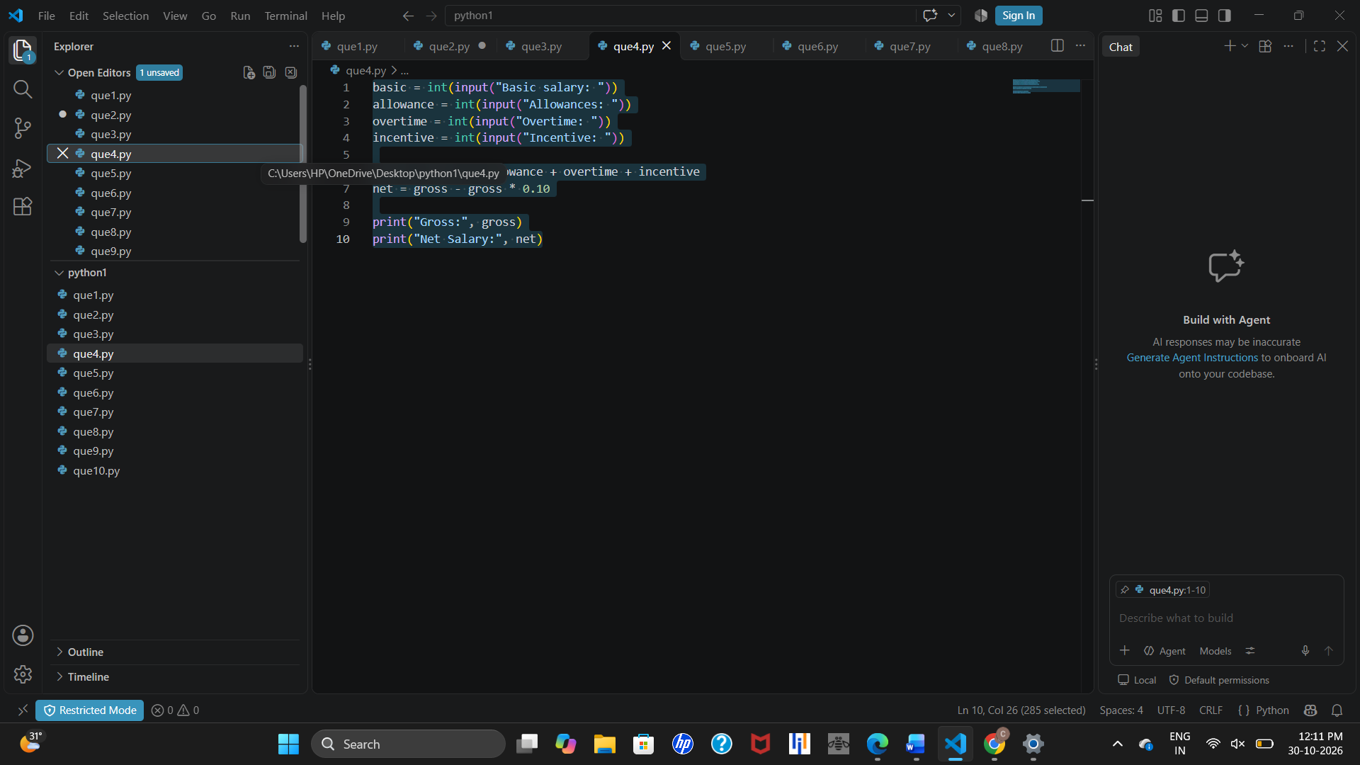10. Conclusion
This system demonstrates variables, arithmetic operations, user input, and calculation of gross and net salary.
Note: The 10% deduction is a simplified assumption and does not necessarily represent actual payroll deductions.

Program 5: Mobile Data Plan Selection System

1. Problem Statement
Select the first mobile plan whose price does not exceed the customer’s budget, after accepting data usage and budget.

2. Objectives
- Accept data usage in GB and customer budget.
- Store available plan prices in a list.
- Check plans against the budget.
- Display the first affordable plan or a no-plan message.

3. Assumptions
- Data usage is entered in GB and budget in Indian rupees.
- Plan prices are ₹199, ₹299, and ₹399, checked in ascending order.
- The first plan priced at or below the budget is selected.
- The supplied program accepts data usage but does not use it to determine eligibility.

4. Algorithm
- Start; input data usage and budget.
- Initialize plans = [199, 299, 399].
- Check each plan in order.
- If a plan price ≤ budget, display the eligible plan and stop checking.
- If no plan is affordable, display “No suitable plan”. Stop.

5. Flowchart
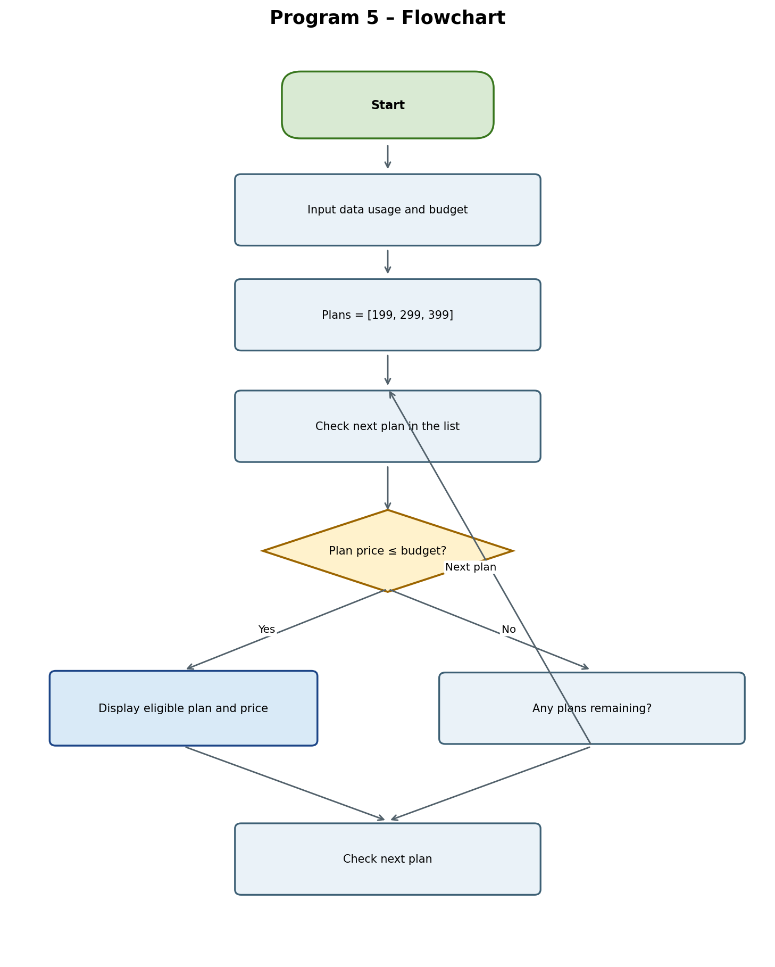

6. Pseudocode
START
INPUT usage, budget
plans = [199, 299, 399]
FOR each plan p in plans
IF p <= budget
DISPLAY "Eligible Plan:", p
EXIT LOOP
END IF
IF no plan was selected
DISPLAY "No suitable plan"
STOP

7. Python Source Code
usage = int(input("Data usage in GB: "))
budget = int(input("Budget: "))

plans = [199, 299, 399]

for p in plans:
if p <= budget:
print("Eligible Plan:", p)
break
else:
print("No suitable plan")

8. Test Cases
Test Case 1: Budget ₹250
Input | Usage 5 GB; Budget 250
Expected output | Eligible Plan: 199
Explanation | ₹199 is the first plan within budget.

Test Case 2: Budget ₹350
Input | Usage 10 GB; Budget 350
Expected output | Eligible Plan: 199
Explanation | The program stops at the first affordable plan, ₹199.

Test Case 3: Budget ₹150
Input | Usage 2 GB; Budget 150
Expected output | No suitable plan
Explanation | All plans cost more than the budget.

Test Case 4: Budget ₹399
Input | Usage 20 GB; Budget 399
Expected output | Eligible Plan: 199
Explanation | The first affordable plan is ₹199; later plans are not checked.

9. Output Screenshots

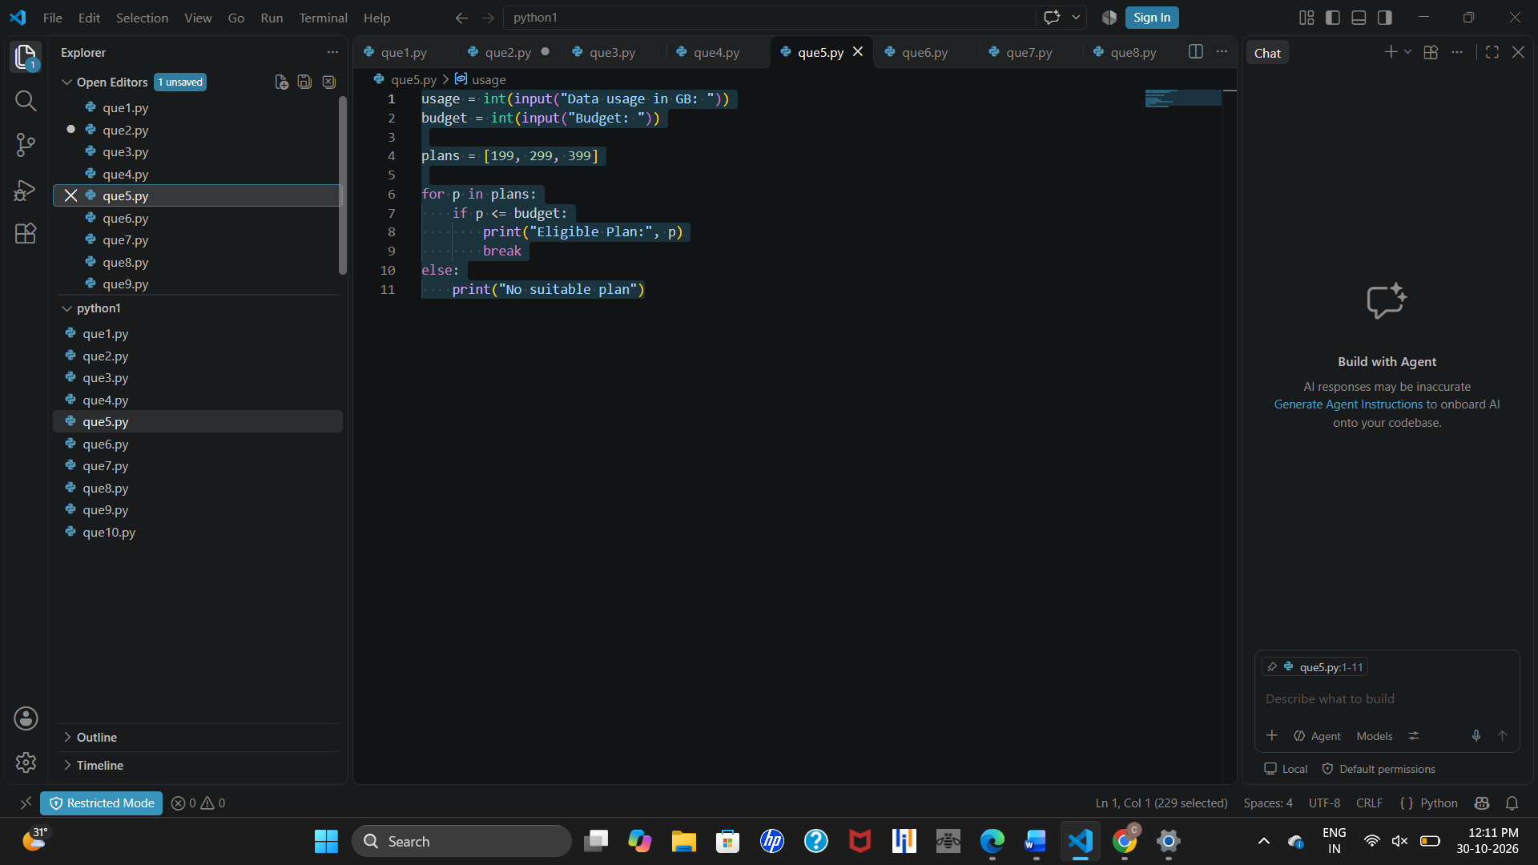10. Conclusion
This program demonstrates lists, for loops, conditional statements, and break to select the first affordable plan.
Note: The current program uses budget alone. Data usage is accepted but does not affect selection; each plan would need a defined data allowance to use that input.

Program 6: Railway Fare Calculation System

1. Problem Statement
Calculate railway fare using travel distance and age, adding a charge for journeys over 100 km and applying a 20% concession to passengers aged 60 or above.

2. Objectives
- Accept travel distance and passenger age.
- Calculate basic fare.
- Add a charge for distance greater than 100 km.
- Apply senior-citizen concession where applicable.
- Display final fare.

3. Assumptions
- Distance and age are non-negative integers.
- Basic fare = ₹2 per kilometre + fixed charge ₹50.
- Add ₹100 when distance > 100 km.
- Passengers aged 60 or above receive 20% concession on the fare, including the additional charge.

4. Algorithm
- Start; input distance and age.
- Calculate fare = distance × 2 + 50.
- If distance > 100, add ₹100.
- If age ≥ 60, multiply fare by 0.8.
- Display railway fare; stop.

5. Flowchart
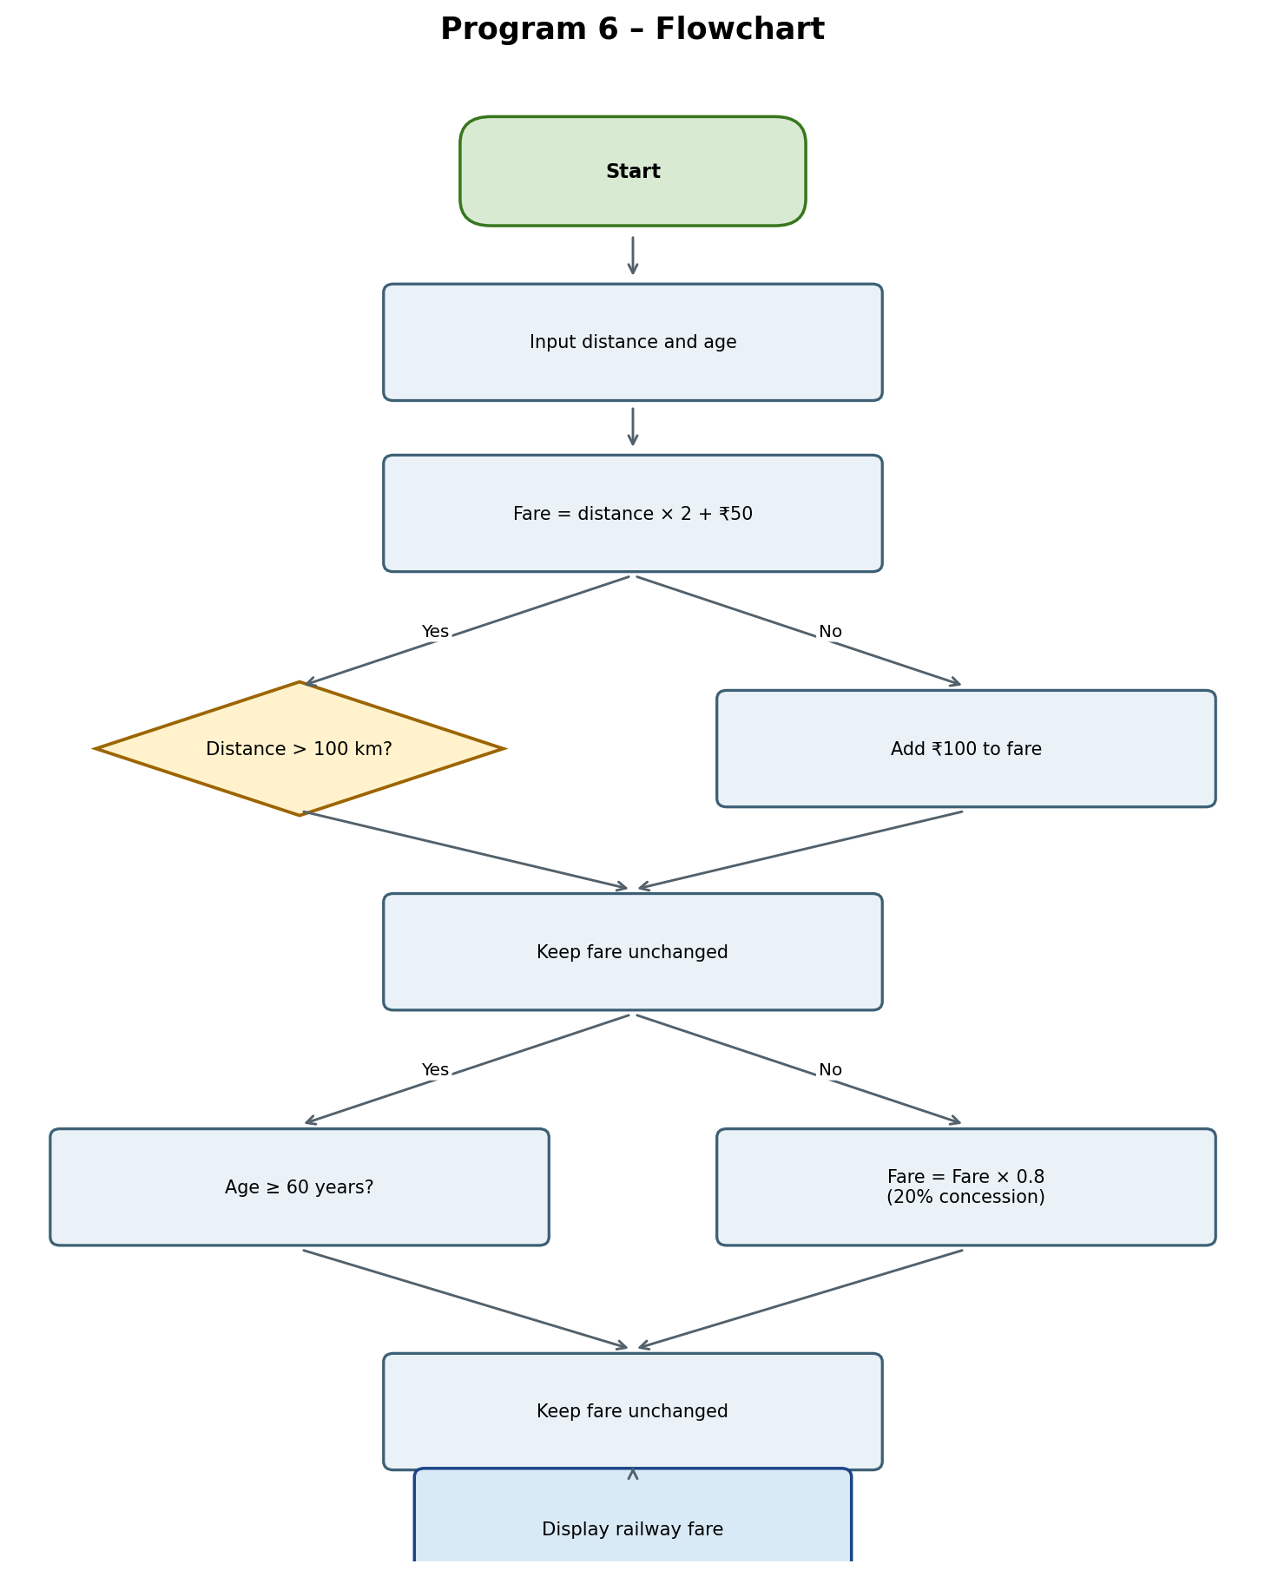

6. Pseudocode
START
INPUT distance, age
fare = distance * 2 + 50
IF distance > 100
fare = fare + 100
END IF
IF age >= 60
fare = fare * 0.8
END IF
DISPLAY fare
STOP

7. Python Source Code
distance = int(input("Distance: "))
age = int(input("Age: "))
fare = distance * 2 + 50

if distance > 100:
fare += 100
if age >= 60:
fare *= 0.8

print("Railway Fare:", fare)

8. Test Cases
Test Case 1: 50 km, age 30
Input | Distance 50; Age 30
Expected output | Railway Fare: 150
Explanation | Basic fare = 50 × ₹2 + ₹50 = ₹150.

Test Case 2: 150 km, age 35
Input | Distance 150; Age 35
Expected output | Railway Fare: 450
Explanation | Basic ₹350 + ₹100 additional charge = ₹450.

Test Case 3: 150 km, age 65
Input | Distance 150; Age 65
Expected output | Railway Fare: 360.0
Explanation | Fare ₹450 less 20% concession (₹90) = ₹360.

Test Case 4: 80 km, age 60
Input | Distance 80; Age 60
Expected output | Railway Fare: 168.0
Explanation | Basic fare ₹210 less 20% concession (₹42) = ₹168.

9. Output Screenshots

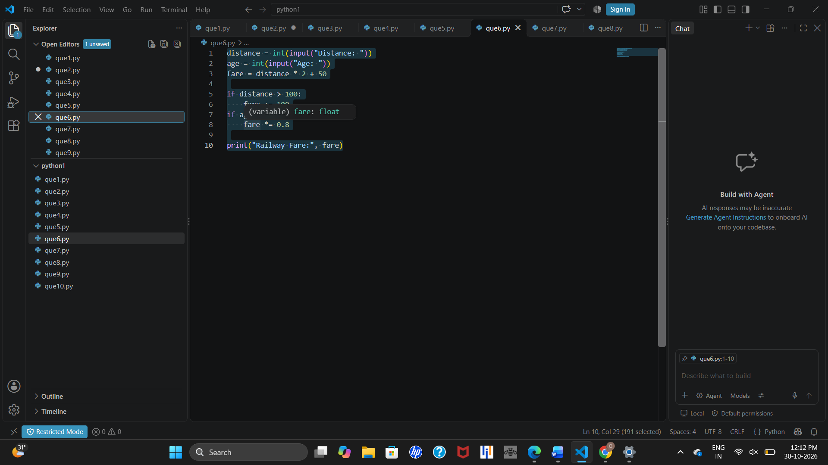10. Conclusion
This case study demonstrates arithmetic calculations and independent if statements to apply distance-based charges and age-based concessions.
Note: The fare rates and concessions are simplified assumptions and do not necessarily represent actual railway fares or policies.

Program 7: Retail Billing System with Discount and Tax

1. Problem Statement
Calculate a customer’s bill from product price and quantity, apply a 10% discount when the total is at least ₹1,000, and add 5% tax to the discounted amount.

2. Objectives
- Accept product price and quantity.
- Calculate total cost.
- Apply a 10% discount at the ₹1,000 threshold.
- Calculate 5% tax on the discounted amount.
- Display final bill.

3. Assumptions
- Product price and quantity are positive integers.
- Total = price × quantity.
- A 10% discount applies when total ≥ ₹1,000.
- Tax is 5% of the amount after discount. All amounts are in Indian rupees.

4. Algorithm
- Start; input price and quantity.
- Calculate total = price × quantity.
- If total ≥ ₹1,000, subtract 10% discount; otherwise retain total.
- Calculate tax = total × 0.05.
- Calculate final bill = total + tax; display and stop.

5. Flowchart
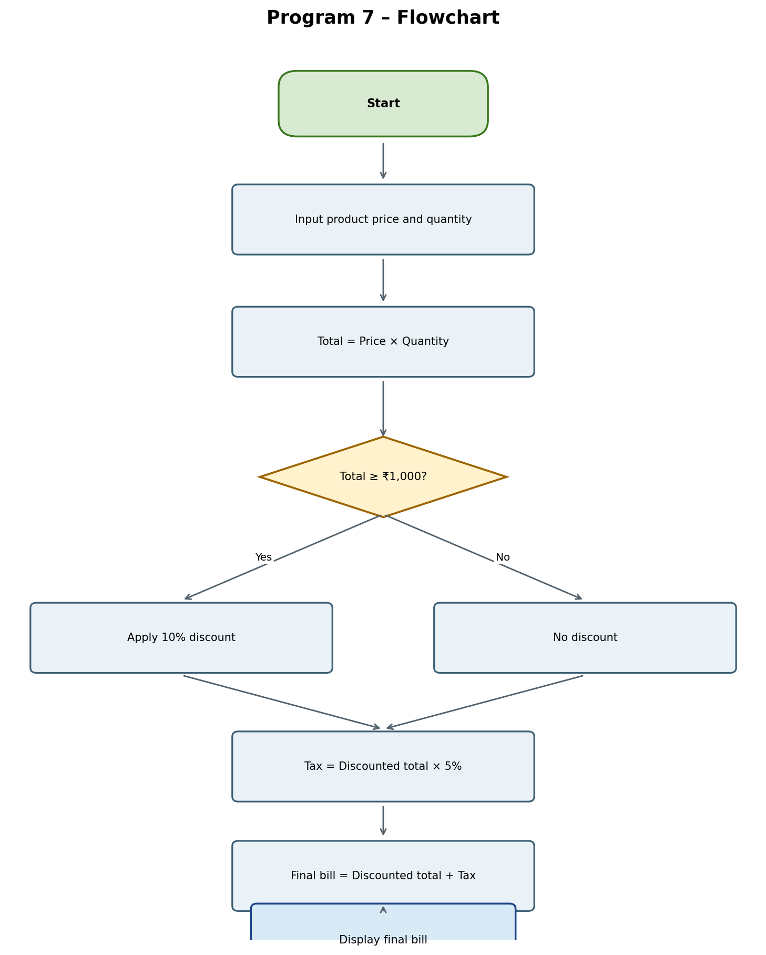

6. Pseudocode
START
INPUT price, quantity
total = price * quantity
IF total >= 1000
total = total - (total * 0.10)
END IF
tax = total * 0.05
final_bill = total + tax
DISPLAY final_bill
STOP

7. Python Source Code
price = int(input("Price: "))
qty = int(input("Quantity: "))

total = price * qty

if total >= 1000:
total -= total * 0.10

tax = total * 0.05
print("Final Bill:", total + tax)

8. Test Cases
Test Case 1: Total below ₹1,000
Input | Price 200; Quantity 3
Expected output | Final Bill: 630.0
Explanation | Total ₹600; no discount; 5% tax ₹30; final ₹630.

Test Case 2: Total above ₹1,000
Input | Price 500; Quantity 3
Expected output | Final Bill: 1417.5
Explanation | Total ₹1,500; discount ₹150; tax ₹67.50; final ₹1,417.50.

Test Case 3: Total exactly ₹1,000
Input | Price 250; Quantity 4
Expected output | Final Bill: 945.0
Explanation | Discount ₹100; tax ₹45; final ₹945.

9. Output Screenshots
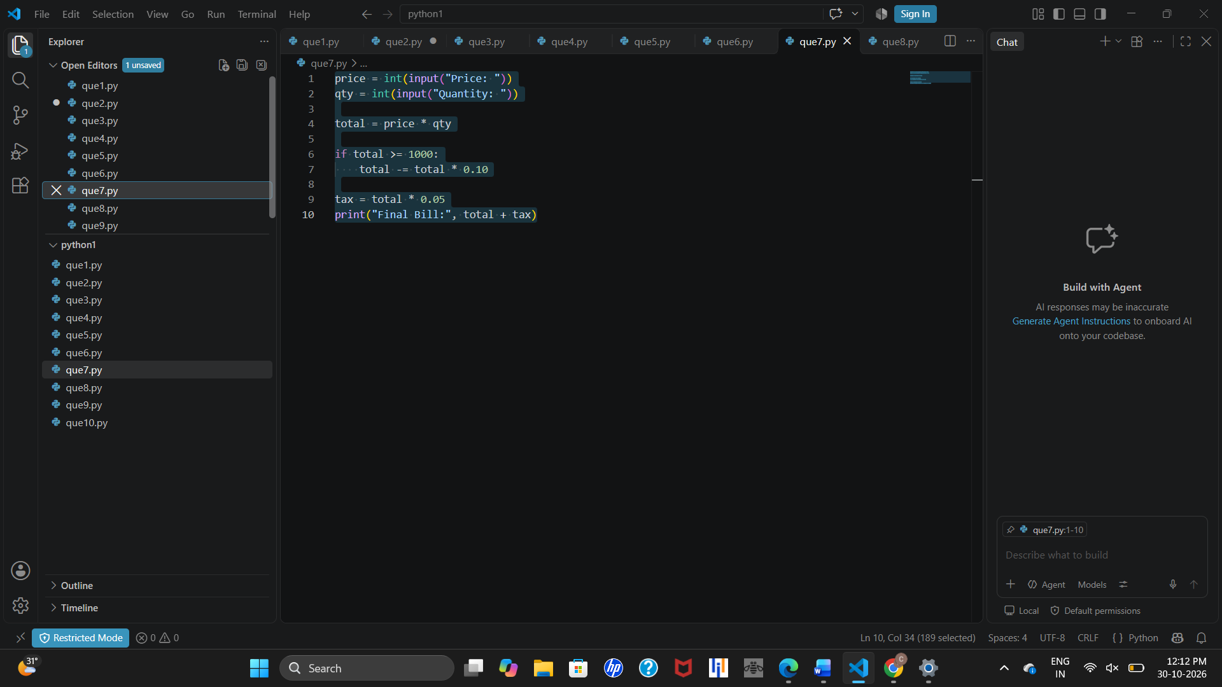.

10. Conclusion
This program demonstrates multiplication, conditional discounting, percentage-based tax calculation, and input/output.
Note: The discount and tax rates are illustrative assumptions and may not represent actual retail tax requirements.

Program 8: Manufacturing Profit Calculation System

1. Problem Statement
Calculate production cost and profit from material, labour, and machine costs and selling price, then check whether profit reaches ₹500.

2. Objectives
- Accept material, labour, machine costs, and selling price.
- Calculate total production cost and profit or loss.
- Check whether profit is at least ₹500.
- Display profit and target status.

3. Assumptions
- All inputs are non-negative integers.
- Production cost = material + labour + machine costs.
- Profit = selling price − production cost.
- Profit ≥ ₹500 means target achieved; otherwise target not achieved.

4. Algorithm
- Start; input material, labour, machine costs, and selling price.
- Calculate cost = material + labour + machine.
- Calculate profit = selling − cost.
- Display profit.
- If profit ≥ ₹500, display “Target Achieved”; otherwise display “Target Not Achieved”. Stop.

5. Flowchart
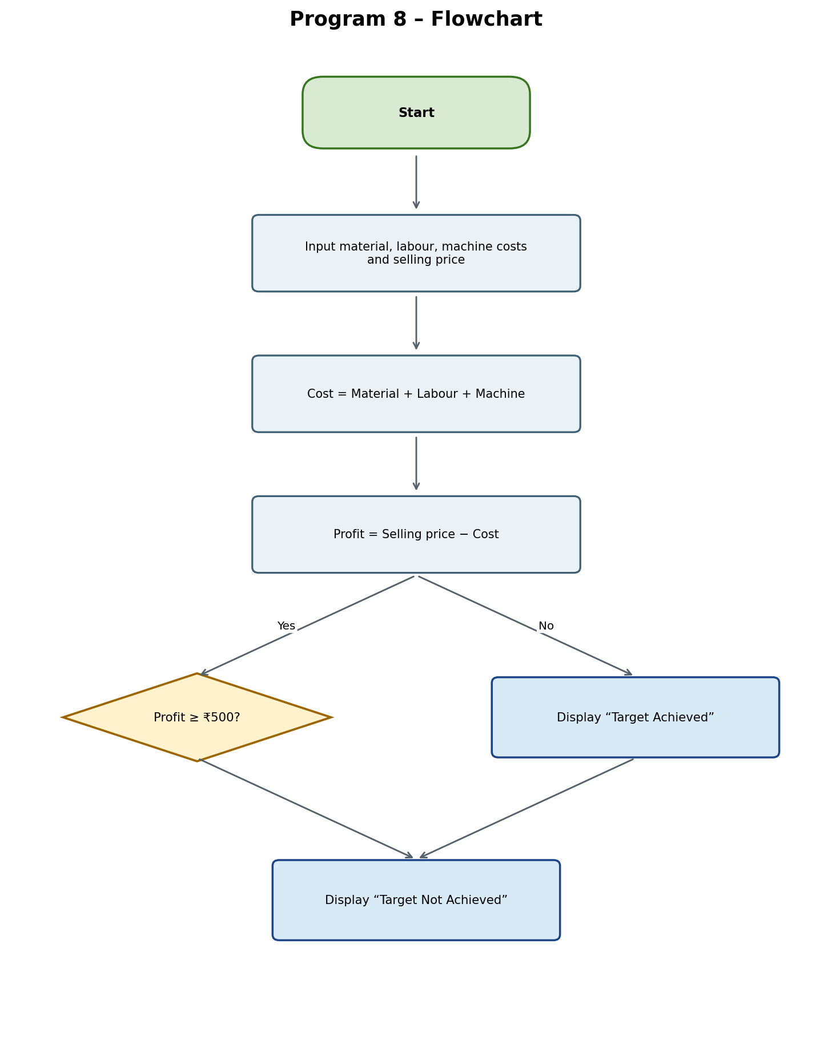

6. Pseudocode
START
INPUT material, labour, machine, selling
cost = material + labour + machine
profit = selling - cost
DISPLAY profit
IF profit >= 500
DISPLAY "Target Achieved"
ELSE
DISPLAY "Target Not Achieved"
END IF
STOP

7. Python Source Code
material = int(input("Material cost: "))
labour = int(input("Labour cost: "))
machine = int(input("Machine cost: "))
selling = int(input("Selling price: "))

cost = material + labour + machine
profit = selling - cost

print("Profit:", profit)
if profit >= 500:
print("Target Achieved")
else:
print("Target Not Achieved")

8. Test Cases
Test Case 1: Target achieved
Input | Material 1000; Labour 500; Machine 300; Selling 3000
Expected output | Profit: 1200; Target Achieved
Explanation | Cost ₹1,800; profit ₹1,200.

Test Case 2: Target not achieved
Input | Material 1000; Labour 500; Machine 300; Selling 2200
Expected output | Profit: 400; Target Not Achieved
Explanation | Cost ₹1,800; profit ₹400, below target.

Test Case 3: Profit exactly ₹500
Input | Material 1000; Labour 500; Machine 300; Selling 2300
Expected output | Profit: 500; Target Achieved
Explanation | Profit equals the target.

Test Case 4: Loss incurred
Input | Material 1500; Labour 800; Machine 500; Selling 2500
Expected output | Profit: -300; Target Not Achieved
Explanation | Production cost ₹2,800 exceeds selling price by ₹300.

9. Output Screenshots

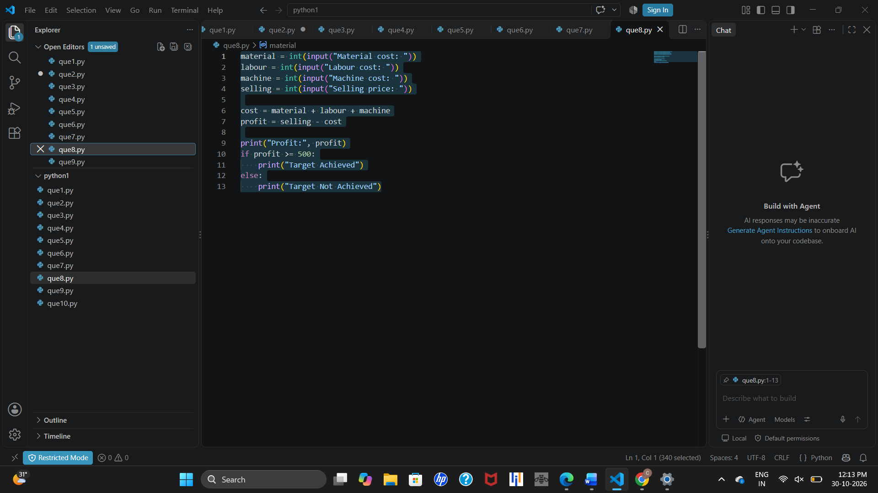10. Conclusion
This system demonstrates cost aggregation, profit/loss calculation, comparison operators, and conditional output.

Program 9: Foreign Travel Expense and Budget Management

1. Problem Statement
Convert a foreign-currency expense using an exchange rate, add a 2% charge, and determine whether the total is within the available budget.

2. Objectives
- Accept foreign expense, exchange rate, and budget.
- Convert the expense into the target currency.
- Add a 2% charge.
- Compare total expense with budget and display status.

3. Assumptions
- Expense, exchange rate, and budget are positive numerical values.
- Exchange rate is target currency received for one unit of foreign currency.
- Converted expense = foreign expense × exchange rate.
- Add 2% to converted expense.
- Total ≤ budget means within budget.

4. Algorithm
- Start; input expense, exchange rate, and budget.
- Calculate total = expense × rate.
- Add 2% charge to total.
- Display total expense.
- If total ≤ budget, display “Within Budget”; otherwise display “Over Budget”. Stop.

5. Flowchart
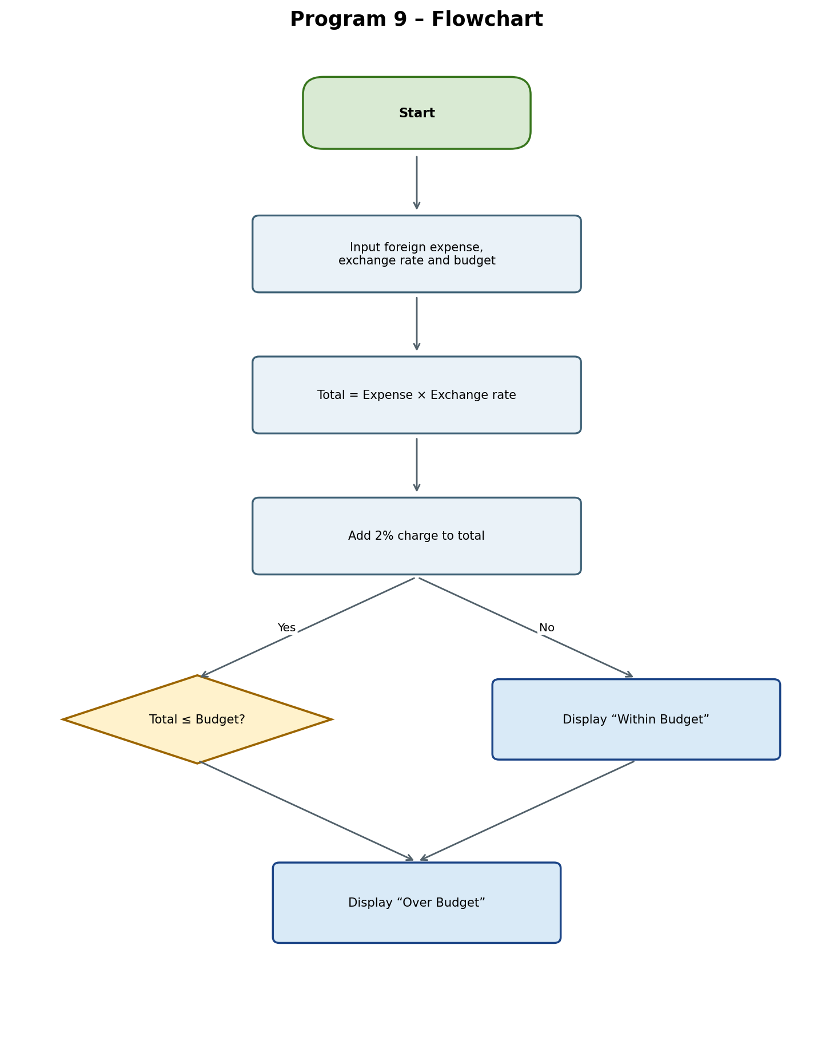

6. Pseudocode
START
INPUT expense, rate, budget
total = expense * rate
total = total + (total * 0.02)
DISPLAY total
IF total <= budget
DISPLAY "Within Budget"
ELSE
DISPLAY "Over Budget"
END IF
STOP

7. Python Source Code
expense = float(input("Foreign expense: "))
rate = float(input("Exchange rate: "))
budget = float(input("Budget: "))

total = expense * rate
total += total * 0.02

print("Total Expense:", total)
if total <= budget:
print("Within Budget")
else:
print("Over Budget")

8. Test Cases
Test Case 1: Within budget
Input | Expense 100; Rate 85; Budget 9000
Expected output | Total Expense: 8670.0; Within Budget
Explanation | Converted ₹8,500 + 2% charge ₹170 = ₹8,670.

Test Case 2: Over budget
Input | Expense 200; Rate 85; Budget 15000
Expected output | Total Expense: 17340.0; Over Budget
Explanation | Converted ₹17,000 + ₹340 charge = ₹17,340.

Test Case 3: Exactly equals budget
Input | Expense 100; Rate 85; Budget 8670
Expected output | Total Expense: 8670.0; Within Budget
Explanation | Total equals the budget and is therefore within budget.

Test Case 4: Small expense
Input | Expense 50; Rate 80; Budget 5000
Expected output | Total Expense: 4080.0; Within Budget
Explanation | Converted ₹4,000 + ₹80 charge = ₹4,080.

9. Output Screenshots
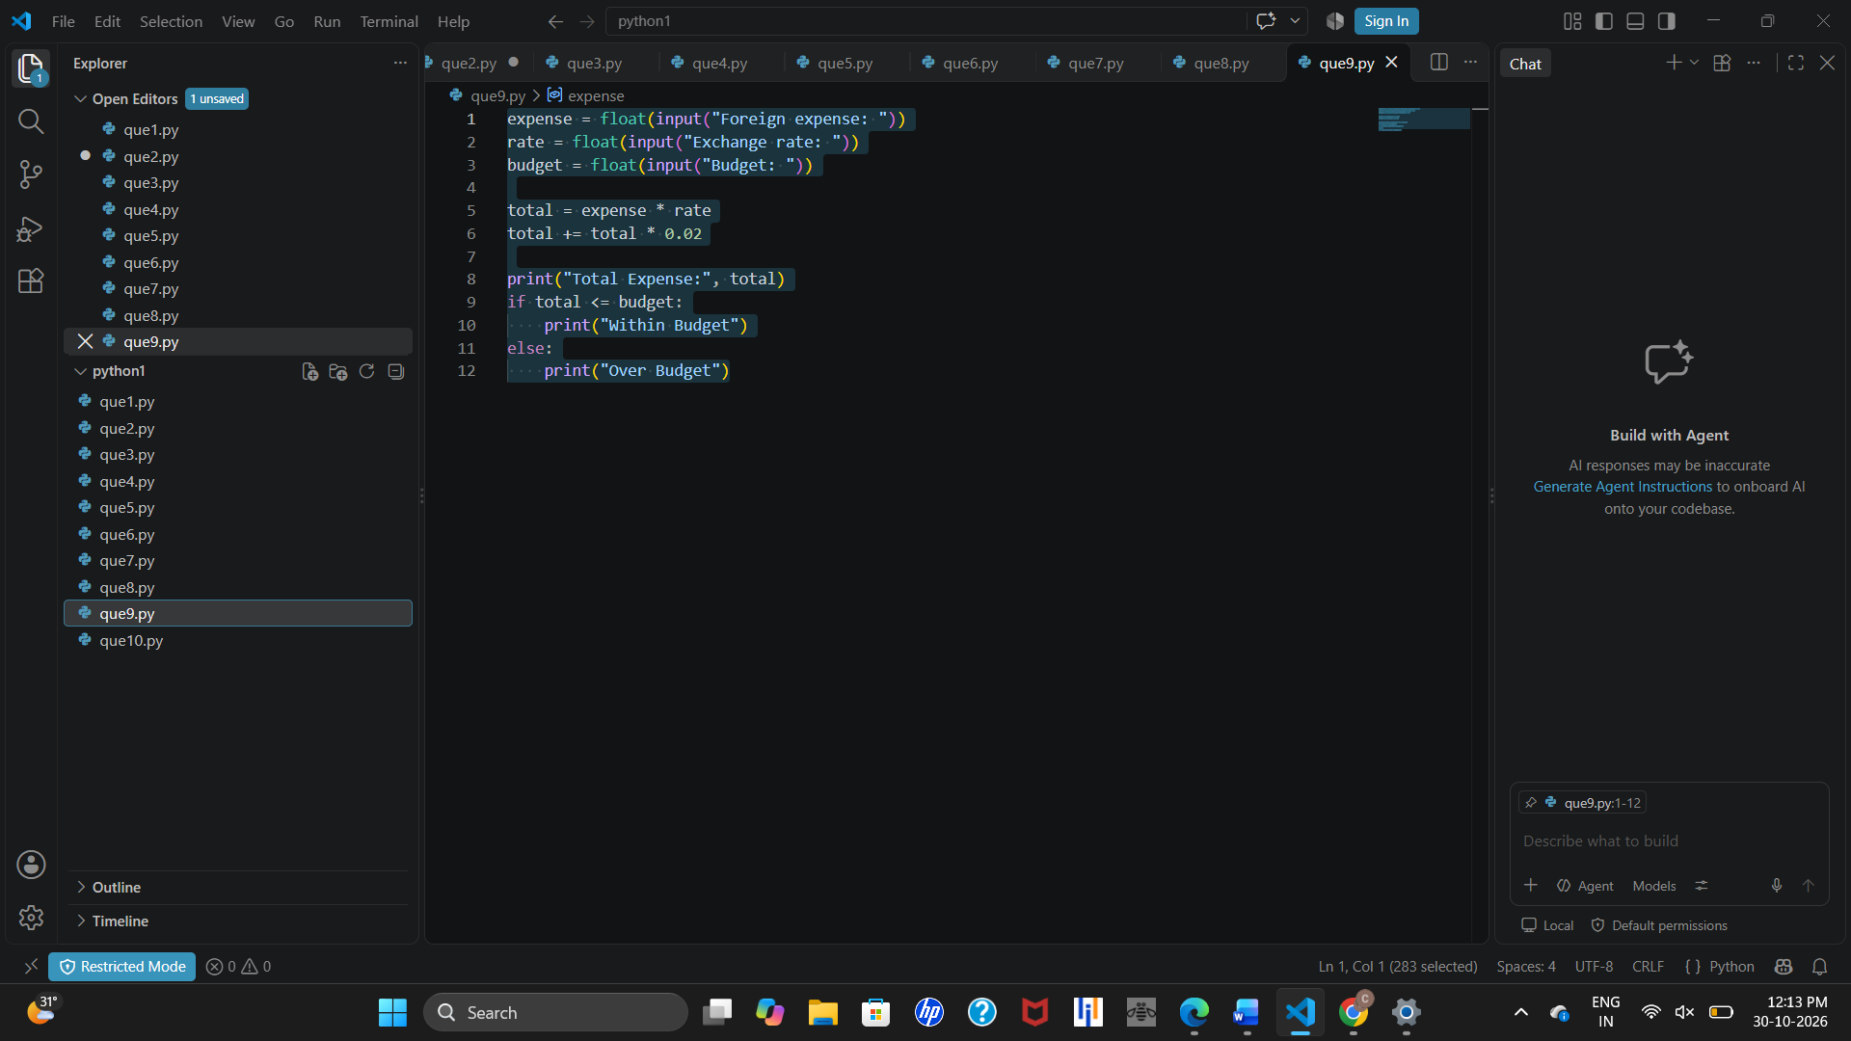

10. Conclusion
This program demonstrates floating-point input, currency conversion, percentage calculations, comparisons, and if-else statements.
Note: Exchange rates and the 2% charge are illustrative; actual exchange rates and transaction fees may vary.

Program 11: Event Management Break-Even Calculator

1. Problem Statement
Calculate total event costs and the minimum whole number of participants needed to cover the expenses, based on a fee per participant.

2. Objectives
- Accept venue, catering, equipment, and transport costs.
- Accept fee per participant.
- Calculate total event cost.
- Calculate and display minimum break-even participants.

3. Assumptions
- Event costs are non-negative integers.
- Fee per participant is a positive integer.
- Total cost is the sum of the four costs.
- Participant count is rounded up to a whole number when division is not exact.

4. Algorithm
- Start; input venue, catering, equipment, and transport costs.
- Input fee per participant.
- Calculate total = venue + catering + equipment + transport.
- Calculate count = (total + fee − 1) // fee.
- Display total cost and break-even participants; stop.

5. Flowchart
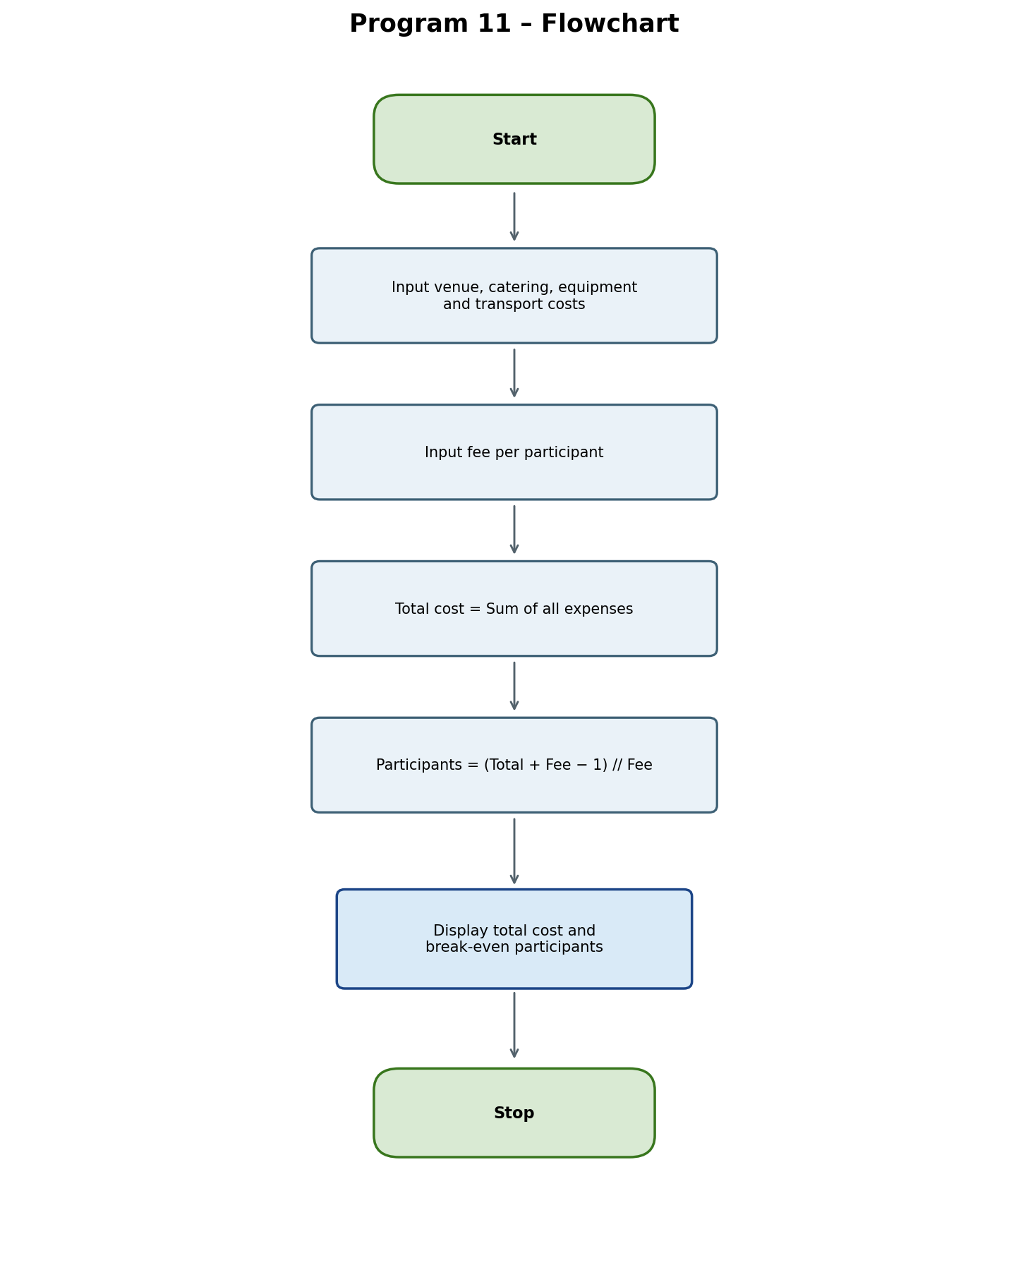

6. Pseudocode
START
INPUT venue, food, equipment, transport, fee
total = venue + food + equipment + transport
count = (total + fee - 1) // fee
DISPLAY total, count
STOP

7. Python Source Code
venue = int(input("Venue cost: "))
food = int(input("Catering cost: "))
equipment = int(input("Equipment cost: "))
transport = int(input("Transport cost: "))
fee = int(input("Fee per participant: "))

total = venue + food + equipment + transport
count = (total + fee - 1) // fee

print("Total Cost:", total)
print("Break-even Participants:", count)

8. Test Cases
Test Case 1: Exactly divisible
Input | Venue 10000; Catering 15000; Equipment 5000; Transport 5000; Fee 500
Expected output | Total Cost: 35000; Break-even Participants: 70
Explanation | Total ₹35,000 ÷ ₹500 = 70 participants.

Test Case 2: Not exactly divisible
Input | Venue 12000; Catering 18000; Equipment 4000; Transport 3000; Fee 500
Expected output | Total Cost: 37000; Break-even Participants: 74
Explanation | ₹37,000 ÷ ₹500 = 74 participants.

Test Case 3: Lower expenses
Input | Venue 2000; Catering 3000; Equipment 1000; Transport 1000; Fee 300
Expected output | Total Cost: 7000; Break-even Participants: 24
Explanation | Ceiling of ₹7,000 ÷ ₹300 = 24 participants.

Test Case 4: Zero event cost
Input | All costs 0; Fee 500
Expected output | Total Cost: 0; Break-even Participants: 0
Explanation | No participants are required when total cost is zero.

9. Output Screenshots

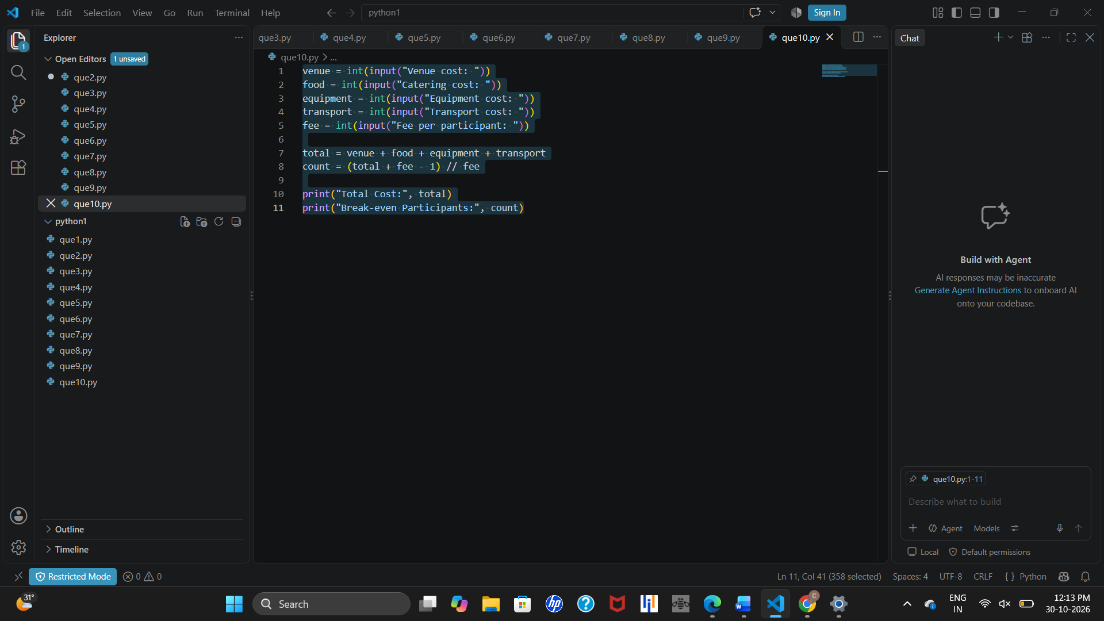10. Conclusion
This calculator demonstrates addition, integer division, and rounding up to find a whole-number break-even participant count.
Note: The fee must be greater than zero to avoid division by zero. The model does not account for per-person variable costs, taxes, or profit targets.

